

**Department of Information Technology**

ACADEMIC YEAR :2019 -2020

Report on Course based project of operating system and computer networks

Title of the project :

**APPLICATION FOR EFFECTIVE MANAGEMENT IN DIAGNOSTIC CENTRES**



**Batch Number:**

JAVEED MEIRA SHAREEF (17071A12G8)

RAJESHWAR SHIVANATHRI (17071A12G9)

NAVATEJ SURAPANENI (17071A12H0)

THARUN KUMAR TALLAPALLI ( 17071A12H1)

SAI HAREESHA THAMTAM (17071A12H2)

**Under the guidance of**

**Mrs.Lavanya Vemulapalli**

Assistant Professor,Information Technology

**Mrs. C. Rohini**

Assistant Professor,Information Technology

**CONTENT:**

* Abstract
* Problem Definition
* Design/Module Description/Methodolgy
* Code
* Result

**Technology Stack:**

**Python tkinter ,NLTK .**

**Abstract:**

Often, getting an appointment to meet a doctor turns out to be a bit of a cruel joke, since the patient turns up on time but ends up meeting the medical practitioner much, much later.This Results in Loss to Diagnostic Centre and Inefficient management System. We Provide a solution for Effective Management in Diagnostic Centers using Scheduling Algorithms.

❏ Scheduling algorithms focuses on the applications of analytical methods to facilitate better decision making.

❏ If scheduling algorithms are used as part of mainstream decision making by diagnostic centre specialists ,then it is easy to solve real world problems faced by the common people in diagnostic centers.

❏ We explained basic applications along with problems with suitable simple solutions through scheduling algorithm techniques.

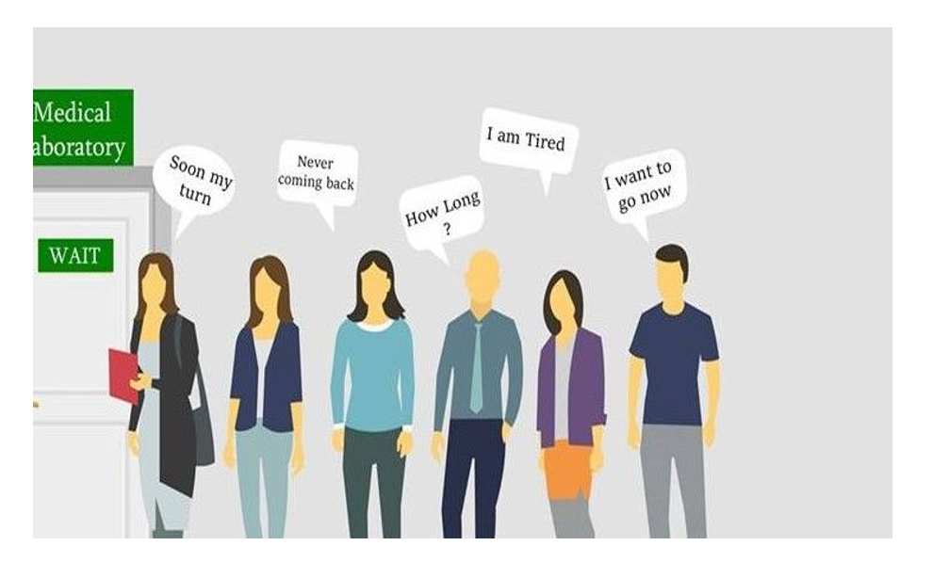

**Problem Definition:**

❏ Viral fevers such as dengue,malaria etc can be treated but Frequently we have to check the malaria parasite at diagnostic centers based on the symptoms of malaria namely suffering fever, headache, joint pain etc., common people are facing so many problems at diagnostic centers at the time of parasite checking. ❏ The following are some of the problems at diagnostic centers along with solutions in different scheduling algorithm approaches.

❏ In India, patients need to make an appointment for a diagnostic centre specialist. In theory, an appointment system reduced patient waiting time. In practice, the waiting time can still be substantial. Various rules and algorithms are used to solve this .

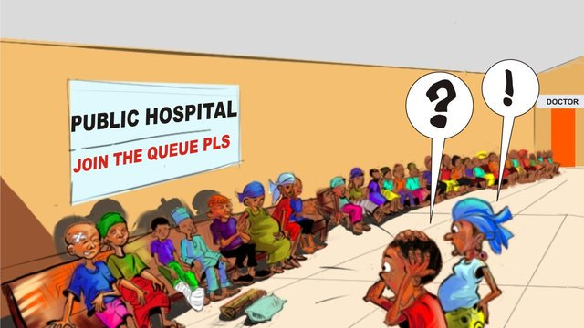

**METHODOLOGY:**

**Problem1: Long waiting time at outpatient clinics before consultation:**

● The first and simplest outpatient appointment scheduling algorithm is first-come, first-served (FCFS) scheduling algorithm. With this scheme, the specialist requests the person first is allocated the bed first for parasite checkup. The implementation of the FCFS policy is easily managed with FIFO queue. When a person enters into the queue for appointment and the specialist is free, person is allocated to the specialist at the head of the queue.

The running person is removed from the queue.

**Problem2: Long time for single consultation:**

● If a patient consulted the doctor , doctor advises MRI scans etc which takes Longer time. In the meanwhile the doctor can treat another patient which is effective . But doctor has to wait until reports are brought by patient to complete the consultation process.

● This can be resolved by using SJF PRE- EMPTIVE SCHEDULING ALGORITHM .

● One patient should consult the doctor and should complete the tests prescribed doctor , in the meanwhile doctor can diagnose another person whose consulting time is less.



**Problem3: Need of Personalized consultation:**

● Some patients desire to have personalized consultation i.e if a patient enters into the consulting room , he/she has to complete the consultation process and next patient should be given a chance.

● But different persons have different number of hours for consultation.

● To achieve effective management with personalized consultation, SJF NON-PREEMPTIVE SCHEDULING ALGORITHM should be implemented i.e a patient who has less consultation period given permission to consultation room.



**Problem4: Emergency consultations are not achieved:**

● Needy and emergency conditioned patients are not being serviced well .

● Old age people , children and other emergency cases have to get consultation first. This can be achieved using PRIORITY SCHEDULING.

● Old age people , children and other emergency cases have to be ranked with high priority and given medication.



**Problem5: Delayed Reports:**

● In Diagnostic centres , for faster blood reports . Eg: Malaria test The Round Robin algorithm is designed especially for time sharing system. RR is similar to FCFS but preemption is added to switch between patients. A small unit of time called time quantum is defined. In the process of parasite checking, there so many steps namely taking blood from the person, preparing blood smear, analysis of smear in microscope and final interpretation etc.,.



In all previous algorithms we have to do all these steps within time allocation of patient.

Wasting of time is possible while using above discussed algorithms between each step of parasite checking. In this method we can avoid wasting of time between each step. In this case, we have give break to patient between each step namely time quantum so that simultaneously we can do work with more than one patient at a time. This leads to saving patient, specialist time and possibility of testing more patients. Here we can minimize average waiting time of patients.

**Code:**

<https://github.com/tharun435>

**Results:**

A User Friendly Interface was developed and Removed the problem of Solving Long Waiting Queues in the Diagnostic Centers.



